**Experimental Graph:**

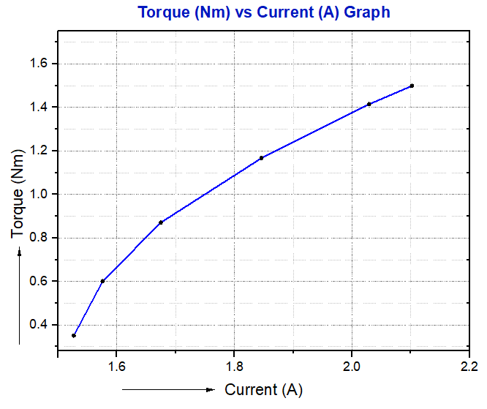

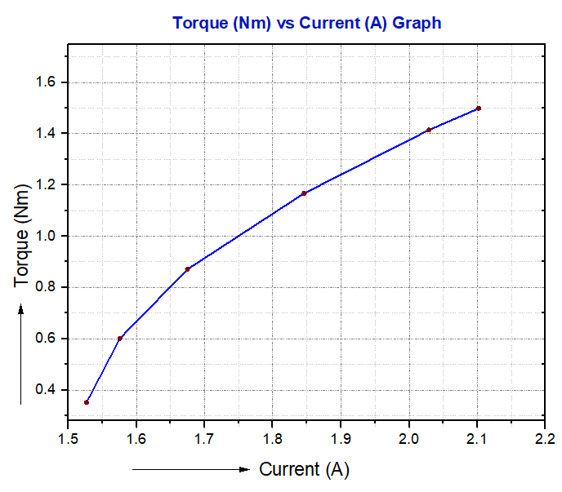



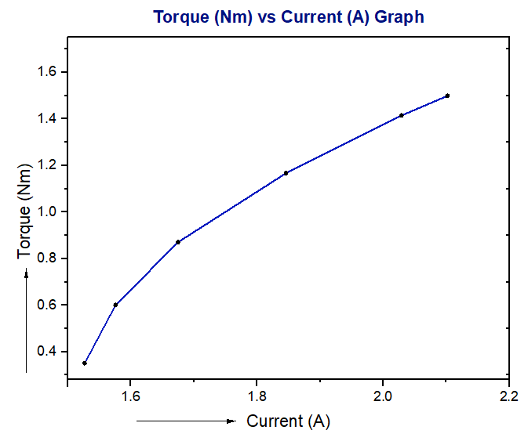

**Figure 01: Current versus Torque Graph for Single phase Motor**

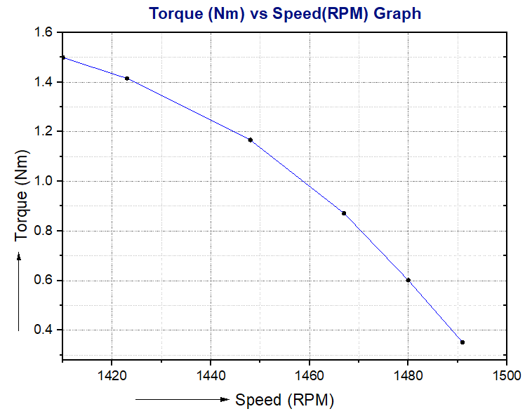

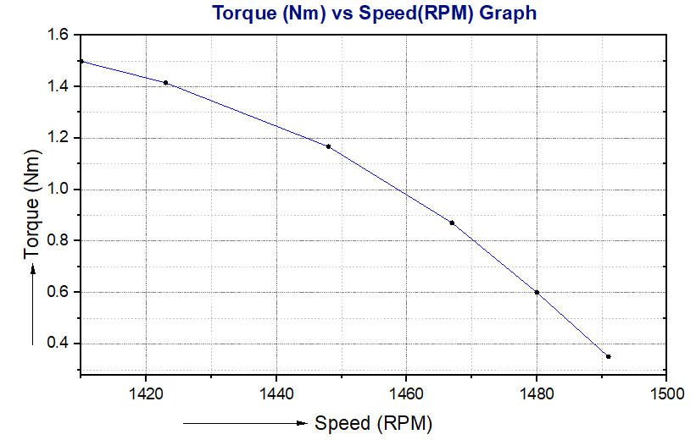

**Figure 02: Speed versus Torque Graph for Single phase Motor**

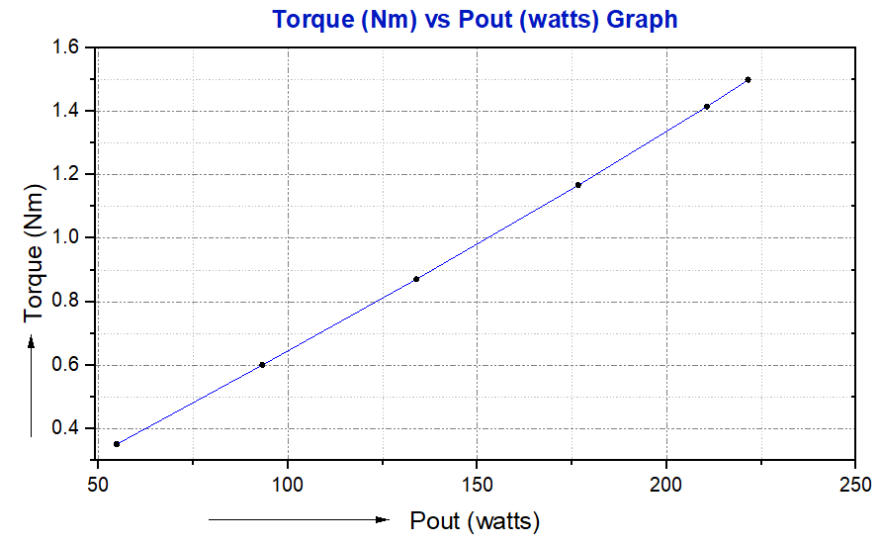

**Figure 03:Pout vs Torque Graph**

**Figure 04: Efficiency vs Torque Graph**